Architecture patterns
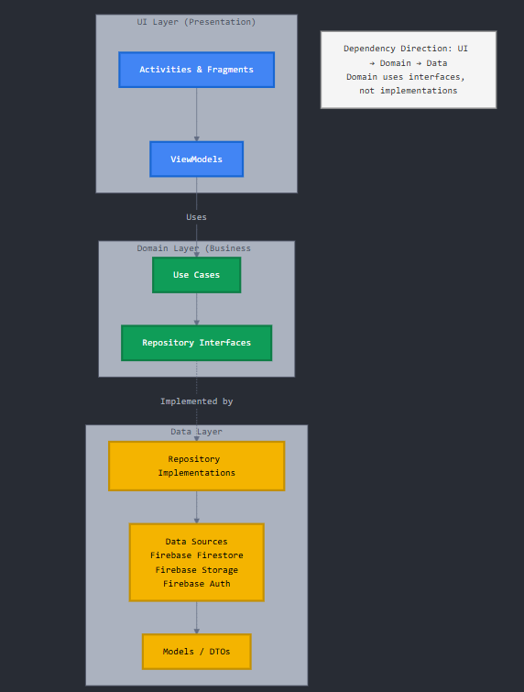 Figure 7: Architecture patterns (Anthropic, 2025)
This diagram shows how your Android app is organized into 3 layers:
1. UI Layer (Blue) - What users see
- Activities & Fragments: The screens (login, attendance, gallery)
- ViewModels: Handle button clicks and prepare data for display
Example: Teacher sees attendance screen and clicks "Mark Present". (Anthropic, 2025)
2. Domain Layer (Green) - Business rules
- Use Cases: Specific actions like "MarkAttendanceUseCase", "UploadMediaUseCase"
- Repository Interfaces: Contracts that say, "I need data" (but don't care where from). (Anthropic, 2025)
Example: Use Case checks if student exists, validates the date, decides to save attendance
3. Data Layer (Yellow) - Where data is stored
- Repository Implementations: The actual code that talks to Firebase
- Data Sources: Firebase Firestore (database), Firebase Storage (files), Firebase Auth (login)
- Models/DTOs: Data formats for transferring information
Example: Repository saves attendance to Firebase Firestore. (Anthropic, 2025)
How it flows:
Teacher taps button → ViewModel calls Use Case → Use Case requests Repository → Repository saves to Firebase → Success flows back up → UI shows confirmation

Referencing
Anthropic. 2025. Claude Code (Version 1.0). [Large language model and code assistant]. Available at: https://www.anthropic.com/claude-code [Accessed: 13 October 2025].

